Step-1: Launch EC2 instance –connect it to VM

Step-2: install terraform using command

1. Install terraform -y
2. Create folder/directory

Cd /mnt/velocity

Create .tf file

Vi test.tf = in that file write a script

provider "aws" {

access_key = "-"

secret_key ="-"

region = "us-east-1" # You can change this to your desired region

}

# Create VPC

resource "aws_vpc" "my_vpc" {

cidr_block = "10.0.0.0/16"

tags = {

Name = "my-vpc"

}

}

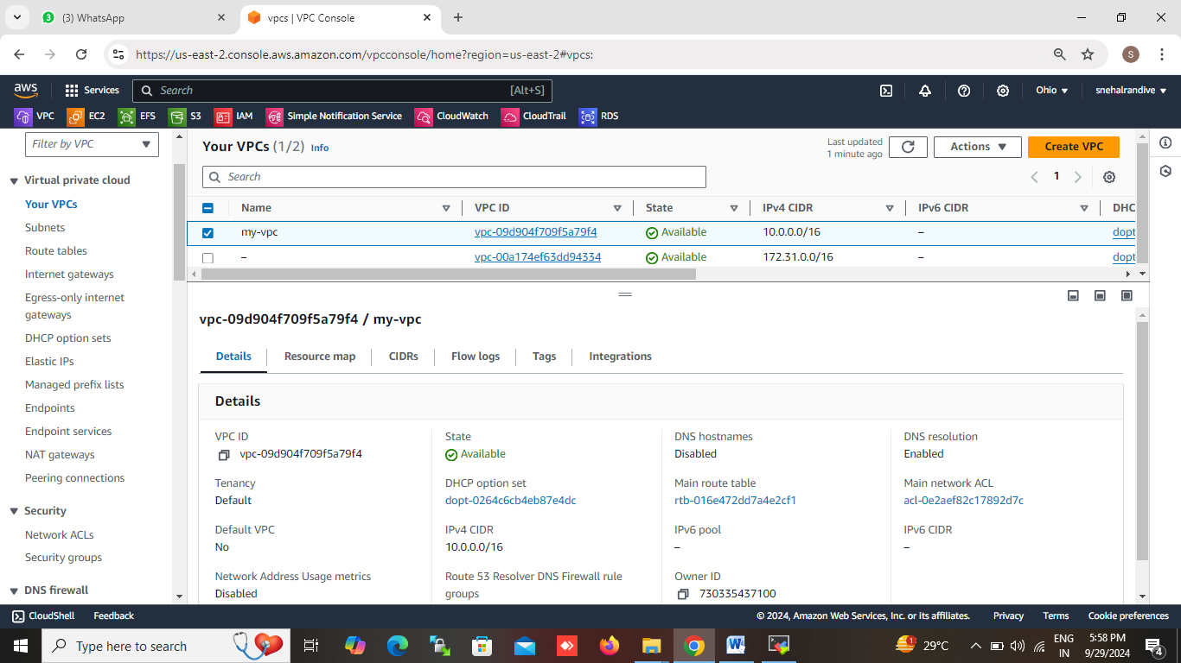

# Create two subnets

resource "aws_subnet" "subnet_1" {

vpc_id = aws_vpc.my_vpc.id

cidr_block = "10.0.1.0/24"

availability_zone = "us-east-1a"

tags = {

Name = "subnet-1"

}

}

resource "aws_subnet" "subnet_2" {

vpc_id = aws_vpc.my_vpc.id

cidr_block = "10.0.2.0/24"

availability_zone = "us-east-1b"

tags = {

Name = "subnet-2"

}

}

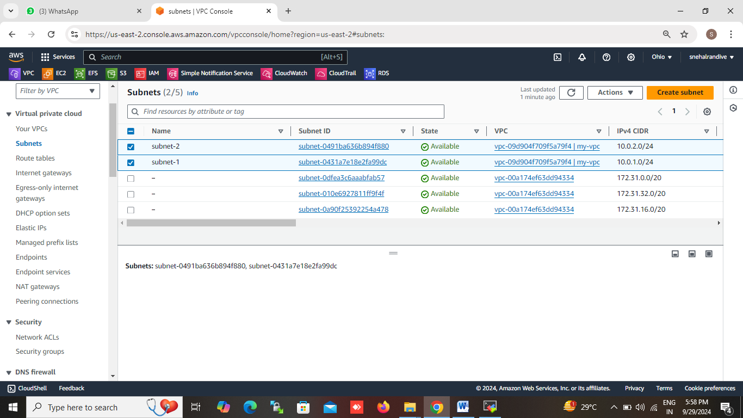

# Create Internet Gateway

resource "aws_internet_gateway" "igw" {

vpc_id = aws_vpc.my_vpc.id

tags = {

Name = "my-igw"

}

}

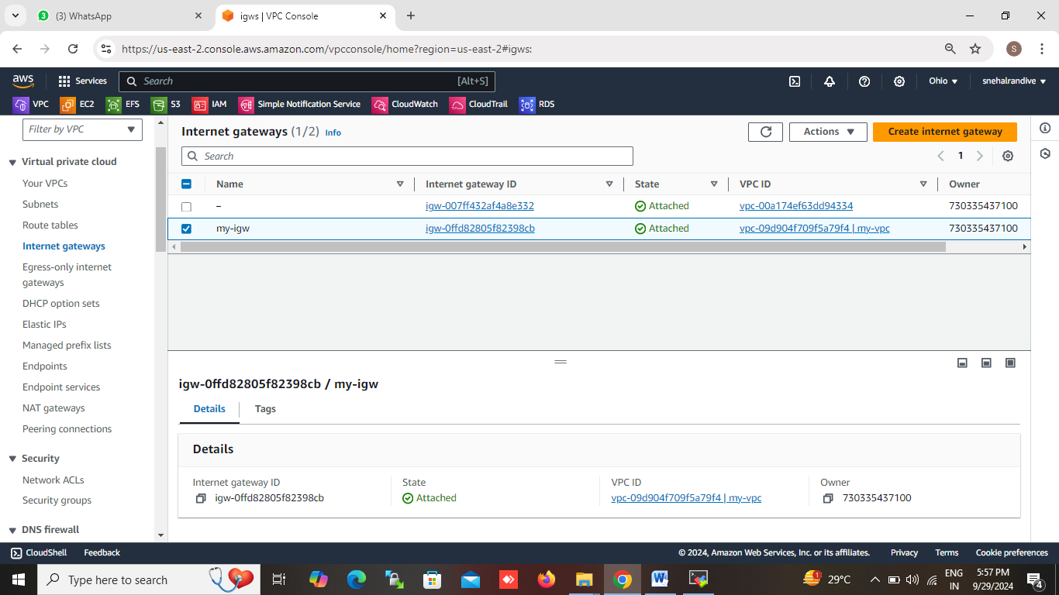

# Create route table

resource "aws_route_table" "route_table" {

vpc_id = aws_vpc.my_vpc.id

route {

cidr_block = "0.0.0.0/0"

gateway_id = aws_internet_gateway.igw.id

}

tags = {

Name = "my-route-table"

}

}

# Associate the subnets with the route table

resource "aws_route_table_association" "subnet_1_association" {

subnet_id = aws_subnet.subnet_1.id

route_table_id = aws_route_table.route_table.id

}

resource "aws_route_table_association" "subnet_2_association" {

subnet_id = aws_subnet.subnet_2.id

route_table_id = aws_route_table.route_table.id

}

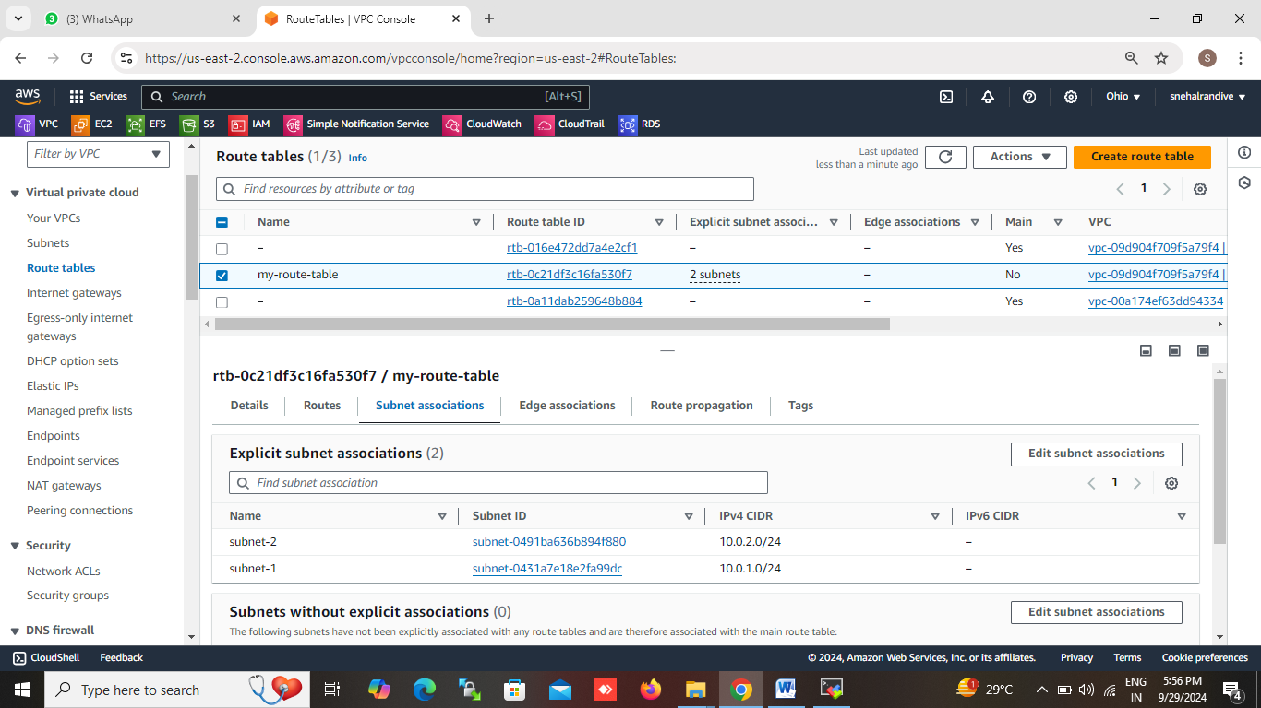

# Create a security group to allow HTTP and SSH

resource "aws_security_group" "allow_http_ssh" {

vpc_id = aws_vpc.my_vpc.id

ingress {

from_port = 80

to_port = 80

protocol = "tcp"

cidr_blocks = ["0.0.0.0/0"]

}

ingress {

from_port = 22

to_port = 22

protocol = "tcp"

cidr_blocks = ["0.0.0.0/0"]

}

egress {

from_port = 0

to_port = 0

protocol = "-1"

cidr_blocks = ["0.0.0.0/0"]

}

tags = {

Name = "allow-http-ssh"

}

}

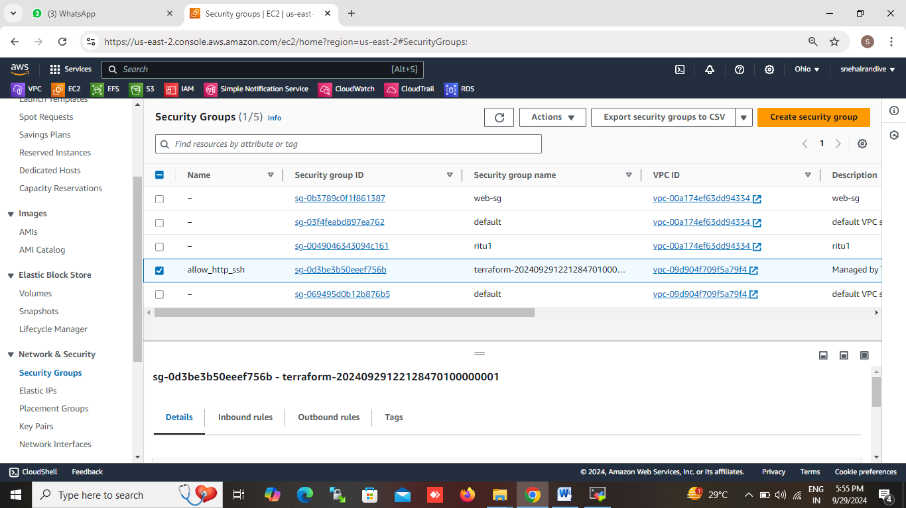

# Launch EC2 instance

resource "aws_instance" "web" {

ami = "ami-id”

instance_type = "t2.micro"

subnet_id = aws_subnet.subnet_1.id

security_groups = [aws_security_group.allow_http_ssh.name]

associate_public_ip_address = true ## show the public ip of the instance

user_data = <<-EOF

#!/bin/bash

yum update -y

yum install -y httpd

systemctl start httpd

systemctl enable httpd

echo "<h1>Hello from Terraform!</h1>" > /var/www/html/index.html

EOF

tags = {

Name = "WebServer"

}

}

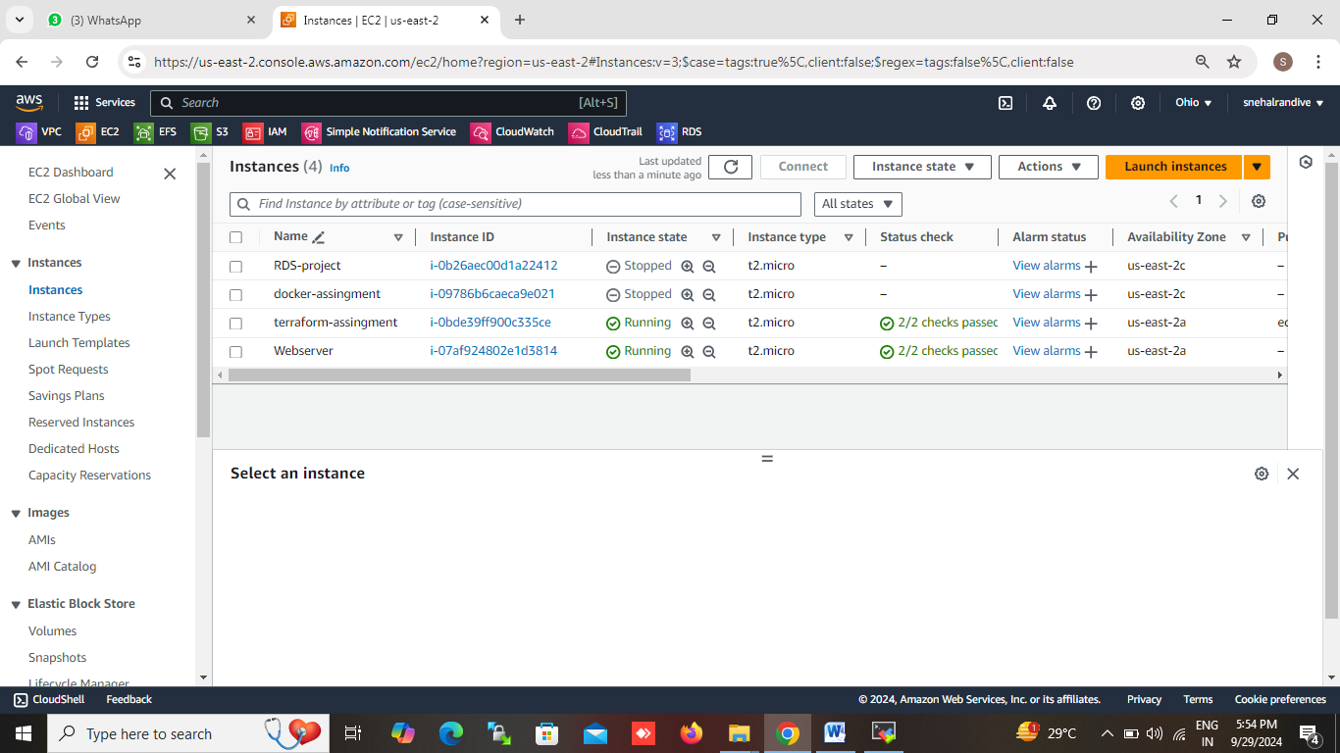

# Output the public IP of the instance

output "instance_public_ip" {

value = aws_instance.web.public_ip

}

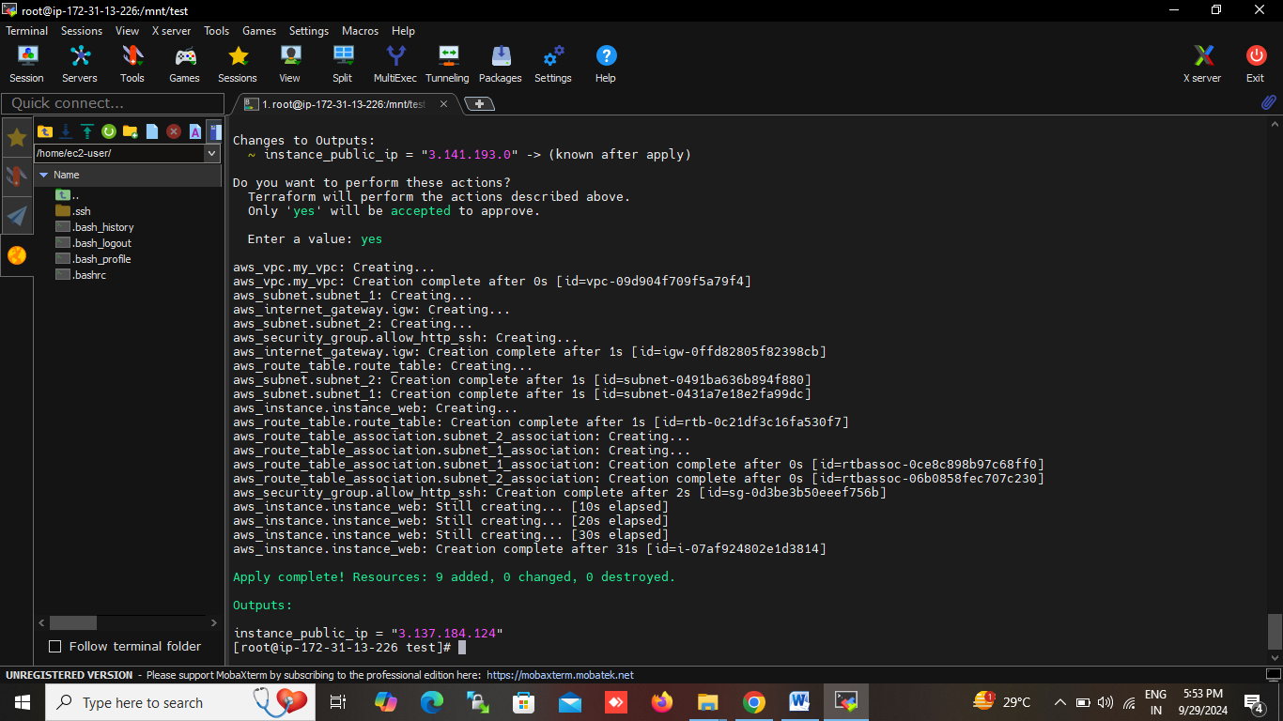

Step-3: save and exit

Step-4: run the commande terraform init = to create or initialize the terraform folder

Run the terraform plan = to dry run to only check if script is execute or not

Run the terraform apply = to apply the script .